CORR-proceduren

2 Variabler: Pulse Time

Enkel statistik

Variabel Ant. Medelvärde Stdavv. Summa Minimum Maximum

Pulse 23 140.04348 9.46994 3221 124.00000 156.00000
Time 23 35.05870 0.72867 806.35000 33.93000 36.17000

Pearsons korrelationskoefficienter, N = 23
Sannol. > |r| under H0: Rho=0

Pulse Time

Pulse 1.00000 -0.74598
<.0001

Time -0.74598 1.00000
<.0001

Exercise 14.9
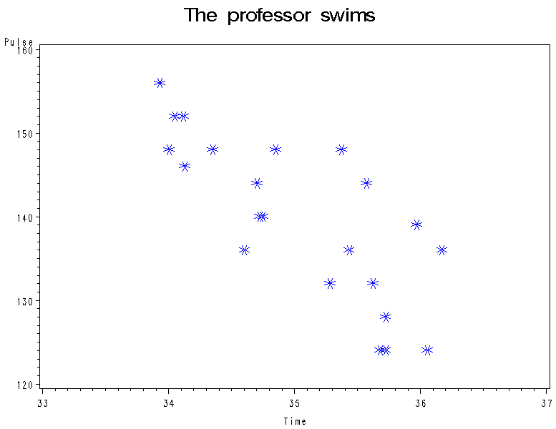
Exercise 14.10 (a)

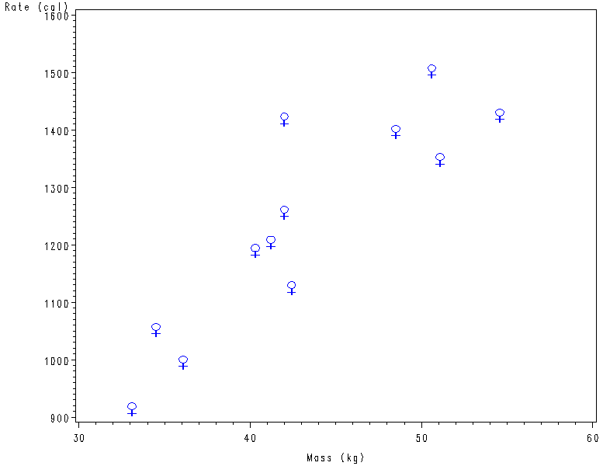

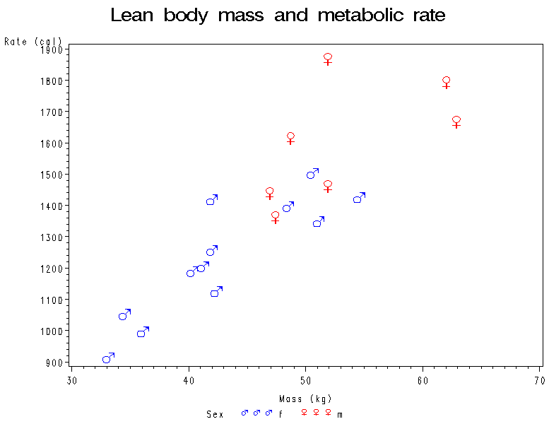

------------------------------ Sex=f --------------------------------------

CORR-proceduren

2 Variabler: Mass Rate

Enkel statistik

Variabel Ant. Medelvärde Stdavv. Summa Minimum Maximum Etikett

Mass 12 43.03333 6.86842 516.40 33.100 54.60 Mass (kg)
Rate 12 1235 188.28289 14821 913.00 1502 Rate (cal)

Pearsons korrelationskoefficienter, N = 12
Sannol. > |r| under H0: Rho=0

Mass Rate

Mass 1.00000 0.87645
Mass (kg) 0.0002

Rate 0.87645 1.00000
Rate (cal) 0.0002

-------------------------------- Sex=m ------------------------------------

CORR-proceduren

2 Variabler: Mass Rate

Enkel statistik

Variabel Ant. Medelvärde Stdavv. Summa Minimum Maximum Etikett

Mass 7 53.100 6.68855 371.700 46.90 62.90 Mass (kg)
Rate 7 1600 189.23971 11200 1362 1867 Rate (cal)

Pearsons korrelationskoefficienter, N = 7
Sannol. > |r| under H0: Rho=0

Mass Rate

Mass 1.00000 0.59207
Mass (kg) 0.1614

Rate 0.59207 1.00000
Rate (cal) 0.1614

Exercise 14.12
