Moore & Notz, exercise 11.6

The highway fuel consumption (midsize cars)

UNIVARIATE-proceduren
Variabel: MPG
Moment
N | 31 | Summa observationer | 825
Medel | 26.6129032 | Varians | 14.911828
Std.avvikelse | 3.86158361

Grundläggande statistiska mått
Placering |  | Spridning
Medel | 26.61290 | Std.avvikelse | 3.86158
Median | 27.00000 | Varians | 14.91183
Mode | 28.00000 | Intervall | 20.00000

Kvantiler (definition 5)
Kvantil | Skattning
100% Max. | 34
75% Q3 | 28
50% Median | 27
25% Q1 | 25
0% Min. | 14

Gren Blad #
34 00 2
32 0 1
30 0 1
28 0000000000 10
26 00000000 8
24 00000 5
22 00 2
20
18 0 1
16
14 0 1
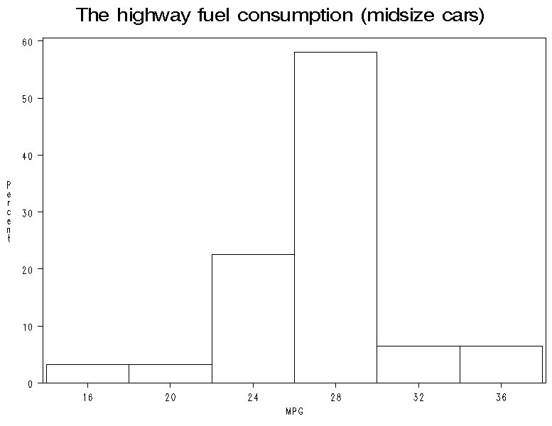

Moore & Notz, exercise 11.8

Salaries of the New Yourk Yankees, 2004

Moment
N | 28 | Summa vikter | 28
Medel | 6453355.32 | Summa observationer | 180693949
Std.avvikelse | 6445700.81 | Varians | 4.15471E13

Grundläggande statistiska mått
Placering |  | Spridning
Medel | 6453355 | Std.avvikelse | 6445701
Median | 3050000 | Varians | 4.15471E13
Mode | 9000000 | Intervall | 21698600
 |  | Interkvartilintervall | 10786071

Kvantiler (definition 5)
Kvantil | Skattning
100% Max. | 22000000
75% Q3 | 11623571
50% Median | 3050000
25% Q1 | 837500
0% Min. | 301400

Histogrambehållare för
salary
Behållare  Minimipunkt | Observerade  procent
0 | 53.571
4000000 | 7.143
8000000 | 14.286
12000000 | 14.286
16000000 | 7.143
20000000 | 3.571

Moore & Notz, exercise 11.9

Moore & Notz, exercise 11.14

Age distribution in the Unated States. 1950

Ackumulerad Ackumulerad
age_group Frekvens Procent frekvens procent
ƒƒƒƒƒƒƒƒƒƒƒƒƒƒƒƒƒƒƒƒƒƒƒƒƒƒƒƒƒƒƒƒƒƒƒƒƒƒƒƒƒƒƒƒƒƒƒƒƒƒƒƒƒƒƒƒƒƒƒƒƒƒƒ
1 29.3 19.42 29.3 19.42
2 21.8 14.45 51.1 33.86
3 24 15.90 75.1 49.77
4 22.8 15.11 97.9 64.88
5 19.3 12.79 117.2 77.67
6 15.5 10.27 132.7 87.94
7 11 7.29 143.7 95.23
8 5.5 3.64 149.2 98.87
9 1.6 1.06 150.8 99.93
10 0.1 0.07 150.9 100.00

Age distribution in the Unated States.

Ackumulerad Ackumulerad
age_group Frekvens Procent frekvens procent
ƒƒƒƒƒƒƒƒƒƒƒƒƒƒƒƒƒƒƒƒƒƒƒƒƒƒƒƒƒƒƒƒƒƒƒƒƒƒƒƒƒƒƒƒƒƒƒƒƒƒƒƒƒƒƒƒƒƒƒƒƒƒƒ
1 34.9 11.23 34.9 11.23
2 35.7 11.49 70.6 22.72
3 36.8 11.84 107.4 34.57
4 38.1 12.26 145.5 46.83
5 37.8 12.17 183.3 59.00
6 37.5 12.07 220.8 71.07
7 34.5 11.10 255.3 82.17
8 27.2 8.75 282.5 90.92
9 18.8 6.05 301.3 96.97
10 7.7 2.48 309 99.45
11 1.7 0.55 310.7 100.00

Moore & Notz, exercise 12.9

Gren Blad #
19 015 3
18 2 1
17 2359 4
16
15 3 1
14 067 3
13 5689 4
12
11
10 7 1

Multiplicera Gren.Blad med 10**+1

Moore & Notz, exercise 12.20

The highway fuel consumption

------------------------------------------ size = Midsize ------------------------------------------
Undre
Medelvärde kvartil Median Övre kvartil Minimum Maximum
ƒƒƒƒƒƒƒƒƒƒƒƒƒƒƒƒƒƒƒƒƒƒƒƒƒƒƒƒƒƒƒƒƒƒƒƒƒƒƒƒƒƒƒƒƒƒƒƒƒƒƒƒƒƒƒƒƒƒƒƒƒƒƒƒƒƒƒƒƒƒƒƒƒƒƒƒƒƒƒƒƒƒƒƒƒƒƒƒƒƒƒƒ
26.6129032 25.0000000 27.0000000 28.0000000 14.0000000 34.0000000
ƒƒƒƒƒƒƒƒƒƒƒƒƒƒƒƒƒƒƒƒƒƒƒƒƒƒƒƒƒƒƒƒƒƒƒƒƒƒƒƒƒƒƒƒƒƒƒƒƒƒƒƒƒƒƒƒƒƒƒƒƒƒƒƒƒƒƒƒƒƒƒƒƒƒƒƒƒƒƒƒƒƒƒƒƒƒƒƒƒƒƒƒ

----------------------------------------- size = SUV ----------------------------------------

Undre
Medelvärde kvartil Median Övre kvartil Minimum Maximum
ƒƒƒƒƒƒƒƒƒƒƒƒƒƒƒƒƒƒƒƒƒƒƒƒƒƒƒƒƒƒƒƒƒƒƒƒƒƒƒƒƒƒƒƒƒƒƒƒƒƒƒƒƒƒƒƒƒƒƒƒƒƒƒƒƒƒƒƒƒƒƒƒƒƒƒƒƒƒƒƒƒƒƒƒƒƒƒƒƒƒƒƒ
20.0384615 18.0000000 19.5000000 21.0000000 16.0000000 27.0000000
ƒƒƒƒƒƒƒƒƒƒƒƒƒƒƒƒƒƒƒƒƒƒƒƒƒƒƒƒƒƒƒƒƒƒƒƒƒƒƒƒƒƒƒƒƒƒƒƒƒƒƒƒƒƒƒƒƒƒƒƒƒƒƒƒƒƒƒƒƒƒƒƒƒƒƒƒƒƒƒƒƒƒƒƒƒƒƒƒƒƒƒƒƒƒƒƒƒƒƒƒƒƒƒƒ

