Example 1: Computing Descriptive Statistics for Multiple Variables
This example computes univariate statistics for two variables. The following statements create the data set BPressure, which contains the systolic (Systolic) and diastolic (Diastolic) blood pressure readings for 22 patients:

data BPressure;
length PatientID $2;
input PatientID $ Systolic Diastolic @@;
datalines;
CK 120 50 SS 96 60 FR 100 70
CP 120 75 BL 140 90 ES 120 70
CP 165 110 JI 110 40 MC 119 66
FC 125 76 RW 133 60 KD 108 54
DS 110 50 JW 130 80 BH 120 65
JW 134 80 SB 118 76 NS 122 78
GS 122 70 AB 122 78 EC 112 62
HH 122 82
;
run;

The following statements produce descriptive statistics and quantiles for the variables Systolic and Diastolic:

title 'Systolic and Diastolic Blood Pressure';
proc univariate data=BPressure;
var Systolic Diastolic;
run;

Example 2: Creating a Histogram
This example illustrates how to create a histogram. A semiconductor manufacturer produces printed circuit boards that are sampled to determine the thickness of their copper plating. The following statements create a data set named Trans, which contains the plating thicknesses (Thick) of 100 boards:

data Trans;
input Thick @@;
label Thick = 'Plating Thickness (mils)';
datalines;
3.468 3.428 3.509 3.516 3.461 3.492 3.478 3.556 3.482 3 … 3.466
;
run;

title 'Analysis of Plating Thickness';
proc univariate data=Trans noprint;
histogram Thick / cframe = ligr cfill = blue;
run;

proc univariate data=Trans;
histogram Thick/midpercents vscale=count endpoints=3.425 to 3.6 by .025;
run;

proc univariate data=Trans ;
histogram Thick / midpoints = 3.4375 to 3.5875 by .025 rtinclude;
run;
goptions reset=all;

Example 3: Sorting by the Values of Multiple Variables

data account;
input Company $ 1-22 Debt 25-30 AccountNumber 33-36 Town $ 39-51;
datalines;
Paul's Pizza 83.00 1019 Apex
World Wide Electronics 119.95 1122 Garner
Strickland Industries 657.22 1675 Morrisville
Watson Tabor Travel 37.95 3131 Apex
Boyd & Sons Accounting 312.49 4762 Garner
Bob's Beds 119.95 4998 Morrisville
Tina's Pet Shop 37.95 5108 Apex
Elway Piano and Organ 65.79 5217 Garner
Tim's Burger Stand 119.95 6335 Holly Springs
Peter's Auto Parts 65.79 7288 Apex
Pauline's Antiques 302.05 9112 Morrisville
Apex Catering 37.95 9923 Apex
;

proc sort data=account out=bytown;
by town company;
run;

proc print data=bytown;
var company town debt accountnumber;
title 'Customers with Past-Due Accounts';
title2 'Listed Alphabetically within Town';
run;

Example 4: The MEANS procedure produces simple descriptive statistics for numeric variables.

PROC MEANS DATA= account MEAN STD VAR Q1 MEDIAN Q3 MIN MAX SUM MAXDEC=2;
VAR Debt;
by town;
run;

Example 5: Introduction and description of data
This example uses a data file about 26 automobiles with their make, mpg, repair record, weight, and whether the car was foreign or domestic. The program below reads the data and creates a temporary data file called auto. The graphs shown in this module are all performed on this data file called auto.

DATA auto ;
INPUT make $ mpg rep78 weight foreign;
DATALINES;
AMC 22 3 2930 0
Audi 17 5 2830 1
Audi 23 3 2070 1
BMW 25 4 2650 1
Buick 20 3 3250 0
Buick 19 3 3400 0
Cad. 14 3 4330 0
Cad. 14 2 3900 0
Cad. 21 3 4290 0
Chev. 29 3 2110 0
Datsun 24 4 2280 1
Datsun 21 4 2750 1
;
RUN;

Creating Scatter plots with proc gplot

To examine the relationship between two continuous variables you will want to produce a scattergram using proc gplot, and the plot statement. The program below creates a scatter plot for mpg*weight. This means that mpg will be plotted on the vertical axis, and weight will be plotted on the horizontal axis.

TITLE 'Scatterplot - Two Variables';
PROC GPLOT DATA=auto;
PLOT mpg*weight ;
RUN;

You may want to examine the relationship between two continuous variables and see which points fall into one or another category of a third variable. The program below creates a scatter plot for mpg*weight with each level of foreign marked.
You specify mpg*weight=foreign on the plot statement to have each level of foreign identified on the plot.

TITLE 'Scatterplot - Foreign/Domestic Marked';
PROC GPLOT DATA=auto;
PLOT mpg*weight=foreign;
RUN;

Customizing with proc gplot and symbol statements

The program below creates a scatter plot for mpg*weight with each level of foreign marked. The proc gplot is specified exactly the same as in the previous example. The only difference is the inclusion of symbol statements to control the look of the graph through the use of the operands V=, I=, and C=.

ods html;
SYMBOL1 V=circle C=black I=none;
SYMBOL2 V=star C=red I=none;

TITLE 'Scatterplot - Different Symbols';
PROC GPLOT DATA=auto;
PLOT mpg*weight=foreign / haxis=2000 to 5000 by 500 vaxis=10 to 30 by 5;
RUN;
QUIT;
ods html close;
goptions reset=all;

Symbol1 is used for the lowest value of foreign which is zero (domestic cars), and
symbol2 is used for the next lowest value which is one (foreign cars) in this case.

V= controls the type of point to be plotted. We requested a circle to be plotted for domestic cars, and a star (asterisk) for foreign cars.
I= none causes SAS not to plot a line joining the points.
C= controls the color of the plot. We requested black for domestic cars, and red for foreign cars. (Sometimes the C= option is needed for any options to take effect.)
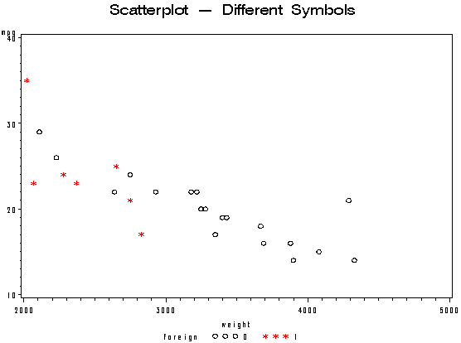

You can easily tell which level of foreign you are looking at, as values of zero are marked with circles in black and values of 1 are marked with asterisks in red. Now if this graph is printed in black and white you will be able to tell the levels of foreign apart.

title 'Comparative Analysis of Lot Source';
proc univariate data=Channel noprint;
class Lot;
histogram Length / nrows = 3
cframe = ligr
cfill = red
cframeside = ligr;
inset mean n = "N" / pos = nw;
run;

